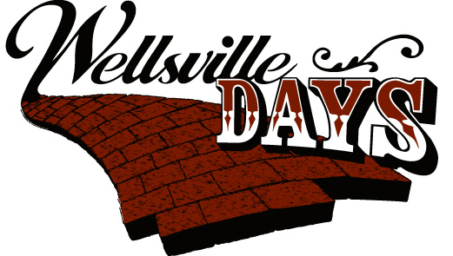

September 22, 2018 – New Sponsorship Levels!!!

Sponsor Level | Platinum  ($5000 +) | Diamond  ($2000) | Emerald ($1,500) | Ruby ($1,000) | Gold ($500) | Silver ($250) | Bronze ($100) | Donation
Recognition On Wellsville Days Website | x | x | x | x | x | x | x | x
Logo/Name on a Saturation Mailer (Approx 1700 Mailboxes) | x | x | x | x | x | x | x
BANNER:  “Sponsor Banner” on Buckeye Supply Stage at 5th & Main  “Top Sponsor Banner” on MAIN STAGE near 6th & Main | “Wellsville Days 2018 brought to you by YOUR NAME” on Top Sponsor Banner | Logo On  Top  Sponsor Banner | Logo On Top Sponsor Banner | Logo On Sponsor Banner | Logo On Sponsor Banner | Logo On Sponsor Banner
Mentions of your business throughout the day from the grandstand | x | x | x | x | x | x
Logo Printed on Event Poster | x | x | x | x | x
One URL link from your logo on the website to your own website | x | x | x | x
Free Booth Space | x | x | x | x
Logo on WD 2018 T-Shirts (worn by all staff, volunteers, and 5K participants) | x | x
“Wellsville Days 2018 brought to you by YOUR NAME” on top of ALL website pages, & on all flyers, mailers, posters. | x

Your sponsorship generosity will go towards funding many items such as the following:
*Saturday Night Performance *Porte Potties
*Ensuring we have a good stage and PA system for our entertainers.
* Bringing back the Kids’ Zone area and exotic petting zoo. *Parade Infusion/Prize Money/Grand Marshall
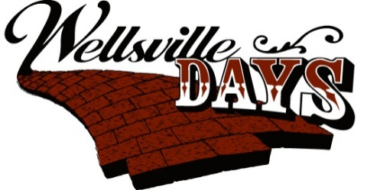
Wellsville Days 2018 Sponsorship Registration
This form can also be filled out online at www.wellsvilledays.com

Contact Name:_________________________________________________________________________________
Company Name:________________________________________________________________________________
Mailing Address For Contact:______________________________________________________________________
______________________________________________________________________
Contact Numbers: Work: ______________________________________________________________________
Cell: ______________________________________________________________________
Email Address: _________________________________________________________________________________
Company’s Web Address: ________________________________________________________________________
Wellsville Days is now a 501©(3) which means Donations can be used as a tax deduction
Please check box if you would like a receipt for tax purpose.
Choose A Sponsorship Level
___Platinum ($5000 +) ___Diamond ($2000) ___Emerald ($1500)
___Ruby ($1000) ___Gold ($500) ___Silver ($250)
____Bronze ($100) ____Donation
Amount: ______________________________________________
*Fund Raiser sponsors will be handled by that particular fund raising committee.(i.e. Golf Tournament)
Payment CK# & Amt Received:_________________________ Date Received:_____________________

Please return to Wellsville Days PO Box 796, Wellsville, KS 66092 or you can e-mail your complete information to sponsorships.wellsvilledays@gmail.com. For Questions contact Natalie at 785-248-1808

Please return to Wellsville Days, Attn: ALICIA JONES, PO Box 796, Wellsville, KS 66092 or you can e-mail your complete information to wellsvilledays@gmail.com. For Questions contact Alicia at 573-280-8109

