2024 Wellsville Days Booth Application

IF YOU PLAN TO PARTICIPATE IN SELLING ITEMS AT WELLSVILLE DAYS PLEASE READ THIS VERY CAREFULLY.
As a vendor it is your responsibility to know and understand these guidelines.
They are put in place for a reason. Thank You!

Please find enclosed information for setting up a booth space at Wellsville Days 2024 and an application to reserve your space.

The theme this year is Wonka’s Wonderful Candy Land
--PLEASE NOTE THAT MAIN STREET BUSINESS MUST STILL REGISGER FOR A BOOTH SPACE TO HAVE THEIR 10X10 SPOT RESERVED.—
We appreciate the support of all the Wellsville downtown businesses and understand this day may affect the normal routine of your business day, however, we hope that everyone will be supportive of both businesses and vendors. So, please take this opportunity to showcase your business!
1. Again this year: All booths, both east and west side of Main Street, will be located in the STREET along the curb. Please keep the sidewalk behind your booth clear, as people will use it to walk along Main. Also be conscious of open businesses. Please keep their doorways clear.
2. ALL Booths MUST complete our booth application. Decisions of acceptance are made by the booth committee and are final. All booth assignments are on a first come first serve basis. Although we will do everything we can to get everyone here, the booth committee holds all rights to decline a booth application if the booth is duplicating another booth or determining if we have too many food vendors, etc. You will be notified immediately if your booth is unfortunately declined for this reason.
3. All booths are ONE DAY ONLY. (Saturday, September 28th, 2024)
4. All booth spaces are a 10 X 10 space. Booth numbers can be found along the curb. We only provide booth space. No tables, chairs, tents, or other items are provided. ( IMPORTANT: You may request a specific location, however, your booth assignment is based on several factors such as your need for electricity, when we received your application, generator noise etc.)
5. If you bring a trailer you will be confined to selling in that trailer, if you would like space outside of that trailer for cooking, you will need to ensure that it is on your registration as you may be charged for additional space.
6. You will be responsible for your own sales tax, display tables, extension cords, electrical strips, water or any materials needed for your display/booth.

~ 2 ~
7. ALL Booths should be set up by 8:00 A.M. and will need to remain in place until 5:00 P.M.(For the safety of our community we CANNOT allow cars driving on Main before this time to load their cars). If it is critical that you leave prior to that time you may find parking as close to the barricades as possible and take your booth items to your vehicle for loading. Those vendors with food trucks and trailers should plan to arrive as near to 6:30 AM as possible to allow for backing in trailers without disturbing other vendors.
8. All displays should be neat in appearance.
9. Any food vendors that utilize a grease product MUST have a way to dispose of the grease and WILL NOT be allowed to dispose of the grease in the city trash barrels.
10. All vendors should have a way to dispose of their own trash if needed. All vendors should have booth items/displays removed from main street by midnight. Any left items will be disposed of.
11. We cannot change booths the day of the show. We appreciate your cooperation with this.
12. How to register:
--Online applications are preferred. You may register online at www.WELLSVILLEDAYSKS.com and your acceptance, space number, and booth map will be e-mailed back to you or mailed if you provide a self-addressed envelope closer to the day of the event. Your booth will not be considered until payment is received. You may pay by credit card/paypal with online registration.
--Should you not have access to the internet, please return the application below with your payment. Send payment to Wellsville Days, attn.: Booth Coordinator, P.O. Box 796, Wellsville, KS. 66092.
13. Prior to the event you will receive a confirmation via e-mail or mail including your final booth number and a booth map. ALL booths will be REQUIRED to check in at the Canopy located outside Wellsville City Hall. NO booths should arrive prior to 6:30 A.M. If you arrive prior to 6:30 A.M. you will need to wait at 4th & Main to check in. (This is right next to Casey’s)
14. Vehicles cannot be parked on Main Street. Vendors may park at the Wellsville High School parking lot located west of 6th and Main, or along the side streets where parking is permitted. NO parking will be allowed inside of the barricades.
15. Questions regarding booth space can be directed to booths@wellsvilledaysks.com

Please keep pages 1-2 for your records

~ 3 ~
For office use only Booth #_______________________________
Payment: CHECK CASH PAYPAL
Booth Type:______________ Check/Paypal_____________ Confirmation:________Map:___________Electricity: YES NO
Application Date:______________________ Outlet Location:__________________________ Generator: YES NO

Wellsville Days Booth Application
Or register online at www.wellsvilledaysks.com
ONE VENDOR REGISTRATION PER FORM PLEASE
Company/Organization Name:_______________________________________________________________________ Contact Name: ________________________________________ Address: ___________________________________ City: ______________________________________ State: ________________ Zip Code: _______________________ Contact Numbers: _________________________________________________________________________________ E-mail Address: __________________________________________________________________________________ How do you want to receive your booth confirmation?
____________ By E-mail (The e-mail provided above will be utilized, if this changes you will need to notify us to obtain your confirmation.
_____________ By Mail. If you would like to receive your confirmation back via mail, please send a self-addressed stamped envelope with this registration.
What type of booth space do you have? Check one
All Booths/Businesses/Food Vendors/ Vendor with Trailer will utilize a 10x10 space.
Additional 10x10 space is $30.00.
Each Extra 10-amp outlet is $25-We are a small town with limited electricity available.
_____ FREE---Wellsville Business (One space allotted in front of your business)-FOR BUSINESS ONLY!
_____$30.00---ALL booths selling a product, fundraising, or informational booth needing NO electricity. _____$60.00---ALL booths selling a product, fundraising, or informational booth IN NEED of electricity. ONE 10 AMP OUTLET (This gets you one of the two available outlets)
_____$50.00---Food vendor needing NO electricity. GENERATORS WELCOME!
_____$80.00---Food vendor in need of electricity. ONE 10 AMP OUTLET (This gets you one of the two available outlets) _____$80.00---Vendor with trailer needing NO electricity. GENERATORS WELCOME! Trailer Size: _______________
_____$100.00-Vendor with trailer IN NEED of electricity.
ONE 10 AMP OUTLET (This gets you one of the two available outlets) Trailer Size: _____________________
Payment MUST BE sent with your registration or online at the time of application submission. Your space will not be reserved until payment is received. SORRY, there will be NO Refunds.
~ 4 ~
Generators Welcome!!!!!!
****Please note if you need another outlet ______ Extra Charge of $25****
********************WE DO NOT HAVE 220 AMP AVAILABLE********************** No. of Spaces: __________ Will you be bringing a generator?______________
Electricity: Will you need Electricity? _________ If yes: # of 10 Amp Outlets-1 included (Extra $25 Charge/Outlet )_______________
**Dimensions of trailer____________________To help us ensure an adequate space for a trailer, counting hitch, etc.
***When you are sent your booth confirmation you will be given the outlet that will be assigned for your booth. Electricity will be assigned on a first come first serve basis. It will be up to the individual booth to ensure you have the electricity you need.
Types of items you will be selling:
_______________________________________________________________________________________________________________________________________________________________________________________________________________________________________________________________________________________________________________ __________________________________________________________________________________________________________________________________________________________________________________________________________
If you are a food vendor list your full menu:
_____________________________________________________________________________________________________________________________________________________________________________________________________________________________________________________________________________________________________________ ______________________________________________________________________________________________________________________________________________________________________________________________________________________________________________________________________________________________________________________________________________________________________________________________________________________________________________________________________________________________________________________________________________________________________________________________________________________________
I have read the above rules and agree to abide by them and understand no refunds are given. If we are unable to accept your application, we will notify you as soon as possible.
Signature_____________________________________________________________
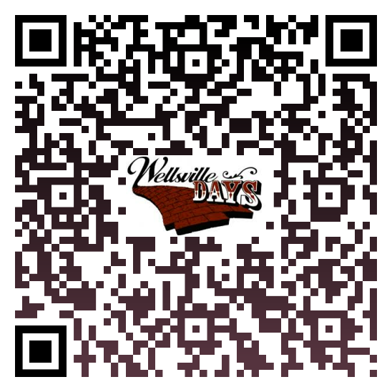
Scan this QR Code to Sign Up Online!

